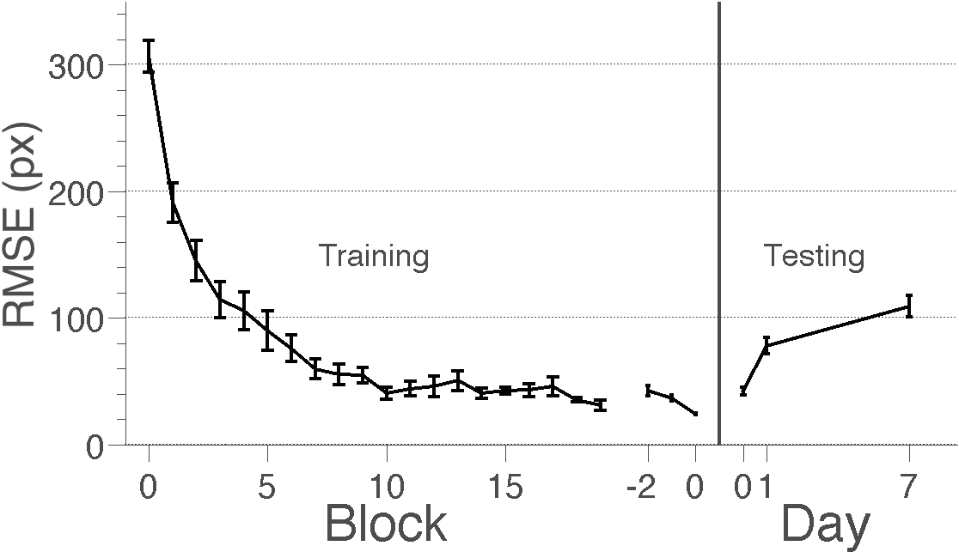
Figure 2. Learning curves from Experiment 1 and the forgetting curve from Experiment 2. Y-axis is the across-subject mean (±1 SEM across-subjects) of the root mean squared error (Euclidean pixel distance between the recalled and the correct object location). Training performance from Experiment 1 is shown on the left (in Blocks) and testing performance from Experiment 2 on the right (in Days). Training performance is shown relative to the beginning of training (Blocks 0 to 20) and relative to the end of training (Blocks -2 to 0) to illustrate criterion performance. Root mean square error (RMSE) decreased during training and increased during testing, indicating the subjects learned and forgot the locations of objects.

